Docker essentials: Extend your apps with containers

https://developer.ibm.com/courses/all/docker-essentials-extend-your-apps-with-containers/

Intro
Containers are a standard way to package an application and all its dependencies so that the application can be moved between environments and run without changes. Containers work by isolating the application inside the container so that everything outside the container can be standardized.

Docker has provided a set of tools to simplify the use of containers. This has led to massive adoption of containers by developers and operators. In this course, you will focus mostly on Docker container technologies.

In this course, you’ll follow a series of hands-on labs that demonstrate how to use containers for your applications. You’ll start with the basics: creating and running your first Docker containers. By the end of the course, you’ll know how to run containers in production with the IBM Container service on IBM Cloud and solve problems of advanced orchestration such as high availability, service discovery, and reconciliation.

Objectives

When you finish this course, you should understand:

What containers are and their benefits
How to find and run Docker containers from the Docker Hub
How to create your first Docker container and understand the layering and union file system
The best practices when developing Dockerfiles
How to solve problems of orchestration: reconciliation, scaling, high availability, and service discovery
Some of the tools that can help you run highly available applications in production, such as the IBM Container service

Labs

Lab 1: Run your first container and learn how to inspect it. Explore the Docker Hub and discover common images ready to be run.
Lab 2: Create a custom Docker Image built from a Dockerfile and push it to a central registry where it can be pulled to be deployed on other environments. Learn about the union file system and copy-on-write, and how they help you deliver applications faster.
Lab 3: Deploy containers using Docker swarm and learn how Docker Swarm helps solve problems such as reconciliation, scaling, high availability and service discovery.

Prerequisites

You don’t need to know anything about containers to take this course, and no extensive programming experience is required. However, you must know how to run command-line tools from your workstation.

If you don’t have Docker already, you need install Docker Community Edition (CE) or use the use the Play-with-Docker website. Docker installations are available from store.docker.com for your Mac, Windows, or Linux machine.

The next section shows you how to install Docker.

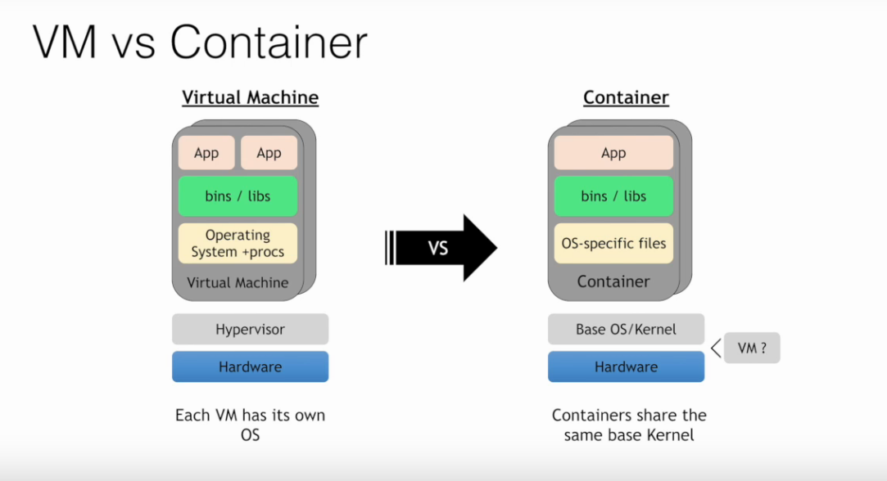

Overview

Containers are just a process (or a group of processes) running in isolation, which is achieved with Linux namespaces and control groups. Linux namespaces and control groups are features that are built into the Linux kernel. Other than the Linux kernel itself, there is nothing special about containers.

What makes containers useful is the tooling that surrounds them. The labs in this course use Docker, which has been the understood standard tool for using containers to build applications. Docker provides developers and operators with a friendly interface to build, ship, and run containers on any environment.

In the first part of this lab, run your first container, and learn how to inspect it. You will be able to witness the namespace isolation that you acquire from the Linux kernel.

After you run your first container, you can explore other uses of docker containers. You can find many examples of these on the Docker Store and can run several different types of containers on the same host, which allows you to see the benefit of isolation—where you can run multiple containers on the same host without conflicts.

You will use a few Docker commands in this lab. If interested, see the full documentation on available commands.
Prerequisites

You must have Docker installed or be using Play-with-Docker.

